Explanatory Notes

**A. Tissue Handling**

Tissue specimens optimally are received fresh/unfixed because of the importance of ancillary studies, such as

cytogenetics and molecular testing, which require fresh tissue. First priority should always be given to formalinfixed

tissues for morphologic evaluation, followed by submission of fresh tissue for cytogenetics and/or snap

freezing a minimum of 100 mg of viable tumor for potential molecular studies.1 Molecular testing on formalin-fixed

paraffin-embedded tissue may be performed for FISH evaluation of EWSR1 rearrangement and for RT-PCR

evaluation of EWSR1-FLI1, EWSR1-ERG, and other ES translocations. When the amount of tissue is limited, the

pathologist can keep the frozen tissue aliquot used for frozen section (usually done to determine sample

adequacy and viability) in a frozen state (-70°C is preferable). Translocations may be detected using RT-PCR on

frozen or fixed paraffin-embedded tissue, or FISH on touch preparations made from fresh tissue or formalin-fixed

paraffin-embedded tissue.

Note that classification of many subtypes of sarcoma is not always dependent upon special studies, such as

cytogenetics or molecular genetics, but frozen tissue may be required to enter patients into treatment protocols.

Discretion should be used in triaging tissue from sarcomas. Adequate tissue should be submitted for conventional

light microscopy before tissue has been taken for cytogenetics, electron microscopy, or molecular analysis.

**B. Procedures**

Cytologic Material

Cytological material is usually sufficient to diagnose ES (with supportive immunostains) (Note G).2 An important

limitation of fine-needle aspiration is the limited amount of tissue for additional molecular diagnostic studies1 and

tissue banking (see Note A). Evaluation by a pathologist at the time of the fine-needle biopsy procedure is

important to assess the adequacy of the specimen for routine histomorphologic diagnosis and for ancillary

studies.

If cytologic material includes fluid, such as pleural effusions or fluid from a liquefactive tumor, the fluid should be

centrifuged and the resulting pellet fixed with formalin prior to making a paraffin cell block. The resulting cell block

allows for histopathologic examination and immunocytochemical, RT-PCR, and FISH analyses.

Biopsy (Needle, Incisional, Excisional)

Core needle biopsies can obtain sufficient material for special studies and histomorphologic diagnosis. Open

incisional biopsy is generally the preferred and most widely used technique, because it consistently provides a

larger sample of tissue and maximizes the opportunity for a specific pathologic diagnosis.3 Excisional biopsy may

not include an adequate margin of normal tissue, even with an operative impression of total gross removal.3

In cases of nonexcisional biopsy (eg, core biopsy, incisional biopsy), the tumor size cannot be determined on

pathologic grounds; therefore, imaging data (computed tomography [CT], magnetic resonance imaging [MRI], etc)

can be used instead.

Tumor Resection

Resection specimens may be intralesional, marginal, wide, or radical in extent.4 Intralesional resections extend

through tumor planes, with gross or microscopic residual tumor identifiable at surgical margins. A marginal

resection involves a margin formed by reactive tissue surrounding the tumor. A wide radical resection has surgical

margins that extend through normal tissue, usually external to the anatomic compartment containing the tumor.

For all types of resections, marking (tattoo with ink followed by use of a mordant) and orientation of the specimen

(prior to cutting) by the surgeon are highly recommended for accurate pathologic evaluation.3 Full representative

mapping of the specimen is also recommended,3 as discussed below.

A full sagittal section of a bone tumor resection specimen,5 as illustrated in Figure 1, allows for mapping of the

entire central face of the tumor and adjacent marginal tissue. Sectioning the specimen in a longitudinal plane that

allows for evaluation of the tumor in its greatest cross-sectional dimension is important. Soft tissue and bone

marrow margins should be inked and taken prior to sectioning the specimen with both amputation and limb

salvage specimens. Freezing of the specimen and cutting with a bone saw (with intraosseous specimens) is the

preferred method. This face of the specimen should be documented using digital imaging photography or

alternatively by a photocopy of the specimen when sealed in a plastic bag. As shown in Figure 1 of an amputation

specimen with soft tissue in place, the central full face of the specimen and lesional region can be mapped and

blocked following fixation and with adequate decalcification for complete microscopic examination, including

estimate of percentage of tumor necrosis. Use of a commercially available formic acid-formaldehyde

decalcification solution is recommended, as this provides a less harsh decalcification method and allows for

retention of antigens for immunohistochemistry and preservation of DNA for possible molecular studies on

formalin-fixed paraffin-embedded tissue.

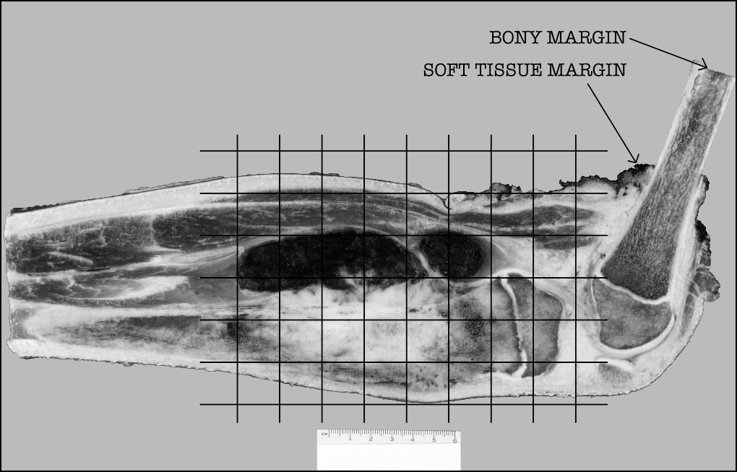

Figure 1. Grid diagram of histologic sections taken, superimposed on photograph of a sagittally-sectioned amputation specimen including the distal femur and proximal tibia.

**C. Extent of Tumor**

Tumors involving the soft tissue of the chest wall and/or the ribs, without conclusive evidence of origin from bone

(Askin tumors), should be denoted as “chest wall.” Medulloblastomas and primitive neuroectodermal tumors of the

central nervous system (CNS) are pathologically different neoplasms and should not be included in this protocol.

However, intracranial ES originating in non-CNS soft tissues such as the meninges should be included.

**D. Margins**

The extent of resection (ie, gross residual disease versus complete resection with negative margins) has the

strongest influence on local control of malignancy.6,7 The definition of what constitutes a sufficiently “wide” margin

of normal tissue in the management of ES and the significance of reactive and/or necrotic tissue at the margin are

current study questions for the Children’s Oncology Group, and may evolve in the future. Currently, any tumor at

the margin, either viable, nonviable, or treated, is considered positive. The significance of treated tumor at the

margin when there has been an excellent chemotherapeutic response (ie, >90% tumor necrosis) remains unclear.

There is currently no consensus as to whether margins involved by treated tumor require further treatment, and

this is considered a negative margin on some studies. The presence of treated tumor at the margin should be

reported, however, and can be included in the comment section of the checklist. The following margins are

considered adequate:

Bone margin: 2 to 5 cm

Fascia, periosteum, and intermuscular septa: 2 mm

Fat, muscle, and medullary bone: 5 mm

With Ewing sarcoma involving an encapsulated organ, surgical margins are considered to be negative if the

organ’s capsule is not surgically violated or breached by the tumor.

**E. Lymph-Vascular Invasion (LVI)**

Lymphovascular invasion (LVI) indicates whether microscopic lymphovascular invasion is identified in the

pathology report. LVI includes lymphatic invasion, vascular invasion, or lymphovascular invasion. Evaluation of

LVI may require immunohistochemical staining for endothelial markers (CD31, CD34, D240, etc). By American

Joint Committee on Cancer (AJCC) and International Union Against Cancer (UICC) convention, LVI does not

affect the T category indicating local extent of tumor unless specifically included in the definition of the T category.

**F. Prognostic Factors**

Typically, ES has a lobular growth pattern consisting of tumor cells that are distinctly monotonous in their nuclear

uniformity. Nuclei measure 10 μm to 15 μm in diameter with distinct nuclear membranes, finely granular

chromatin, and 1 to 2 inconspicuous nucleoli. Cytoplasm is poorly defined, scant, pale-staining, and may be

vacuolated due to irregular glycogen deposition. Atypical variants may show increased nuclear size, more

pronounced atypia, and increased mitotic activity. Multinucleate giant cells are not seen. Large areas of tumor

necrosis with “ghost-like tumor cells” may be striking and in some biopsy specimens may represent the majority of

the tumor. Areas of neuroectodermal differentiation (Homer-Wright rosettes; rarely Flexner-Wintersteiner rosettes

or primitive neuroepithelium) may be evident in some tumors.

Currently, extraosseous Ewing sarcoma receives identical therapy as intraosseous Ewing sarcoma. There are no

histopathologic ES subtypes that possess an established prognostic importance.8

A summary of the prognostic factors is detailed below.9 Of all prognostic factors, age at onset, tumor size, site,

and stage have proven to be the most important in predicting outcome.

Factor Favorable Prognosis Unfavorable Prognosis

Age <10 years (EFS 69%);

10-17 years (EFS 74%)

≥18 years (EFS 44%)

Site Distal extremity (EFS 74%);

Proximal extremity (EFS 62%)

Pelvis (EFS 50%)

Size <8 cm greatest diameter (EFS 75%) ≥8 cm in greatest dimension (EFS 55%)

Stage Nonmetastatic tumor

(EFS approximately 70%)

Metastatic tumor (EFS approximately 20%)

Definition: EFS, event-free survival.

Histologic response to chemotherapy is an excellent predictor of outcome in osteosarcomas and may also be of

value in ES. However, the evaluation of percentage necrosis in ES can be difficult, because unlike osteosarcoma,

there is no residual acellular osteoid framework left to demarcate the original tumor bed. Furthermore, data

regarding correlation of necrosis with outcome in extraosseous ES is not available. Currently, histologic

assessment of percentage necrosis is not used formally to guide therapy in ES; however, it is recommended that

the report includes the estimated percentage of necrosis.

**G. Ancillary Studies**

Immunohistochemistry

Immunohistochemistry with monoclonal antibodies against the cell surface glycoprotein CD99 is positive in

virtually all cases of ES.10 This glycoprotein is diffusely expressed in the vast majority of cases in a membranous

pattern (Figure 2). The results of staining using monoclonal antibodies O13, HBA71, and 12E7 are similar, but

individual tumors may exhibit better staining with one of these antibodies versus other antibodies.



Figure 2. CD99 staining in Ewing sarcoma shows strong, diffuse, membranous staining. (CD99 antibody O13 with hematoxylin counterstain.)

Lymphoblastic lymphomas/leukemias, rhabdomyosarcomas, synovial sarcomas, solitary fibrous tumors, rhabdoid

tumors, neuroendocrine tumors, desmoplastic small round cell tumors, and mesenchymal chondrosarcomas may

also demonstrate immunoreactivity to CD99.8 In some of these tumors, CD99 immunostaining is often weakly

granular and intracytoplasmic; in others (lymphoblastic lymphoma/leukemia, occasional cases of poorly

differentiated synovial sarcoma, alveolar rhabdomyosarcoma), distinct membrane staining is present, as seen in

ES. Because these other tumors with small round cell morphology can exhibit CD99 expression, it is very

important to consider including other immunohistochemical stains such as muscle markers (desmin, musclespecific

actin, myoD1, myogenin), S-100, epithelial markers (epithelial membrane antigen, cytokeratin), INI-1, and

lymphoid markers (CD45, CD30, Tdt, T-cell and/or B-cell markers) when CD99 is performed to properly exclude

CD99-expressing tumors. Cytokeratin positivity may be seen in ES and may be diffusely positive in the

adamantinoma-like variant of Ewing sarcoma.11,12 The value of other immunohistochemical markers for diagnosis,

such as Ki-67, p53, and C-kit (CD117), has not been established. ES is almost always vimentin immunopositive.

Chromosomal Translocations

It is now generally accepted that Ewing sarcoma and PNET form a single group of bone and soft tissue tumors

and the 2013 World Health Organization (WHO) classification of bone and soft tissue tumors uses the single

terminology, Ewing sarcoma. The characteristic translocations involve the EWSR1 gene at 22q12 and either the

FLI1 gene at 11q24 or the ERG gene at 21q22. The presence of t(11;22) (EWSR1-FLI1) and t(21;22) (EWSR1-

ERG) is strongly correlated with ES. The most common gene fusion is the EWSR1-FLI1 (90% to 95% of patients).

It should be emphasized that there are numerous other EWSR1 gene partners that occur in a minority (5% to

10%) of ES. The failure to identify an EWSR1-FLI or EWSR1-ERG translocation by RT-PCR or cytogenetics does

not exclude ES from the diagnosis. Cytogenetic studies are important for identification of the less common and

rare ES translocations and for discovering novel EWSR1 translocations in ES. FISH analysis for EWSR1 is

helpful as a first step and may confirm the diagnosis in those tumors with histomorphologic features and

immunohistochemical phenotypes of ES. Because other small round cell tumors of childhood can have EWSR1

rearrangements with specific tumor-defining partners, EWSR1 FISH positivity alone is not diagnostic of ES. Some

of these tumors with EWSR1 rearrangement include angiomatoid fibrous histiocytoma, clear cell sarcoma of soft

parts, desmoplastic round cell tumor, and extraskeletal myxoid chondrosarcoma, as well as a subset of myxoid

liposarcomas and myoepithelial carcinoma. This underscores the necessity for histologic and

immunohistochemical correlation with FISH and/or cytogenetic data.13

Some of the less common ES translocations include: t(7;22)(p22;q12) EWSR1-ETV1, t(17;22)(q12;q12) EWSR1-

E1AF, t(2;22)(q33;q12) EWSR1-FEV, and t(1;22)(p36;q12) EWSR1-ZSG. In addition, rare cases of ES have been

associated with gene rearrangements involving the FUS gene, and ES-like tumors have been described with CICDUX4

and BCOR–CCNB3.14

The diagnosis of ES is not dependent upon identifying a “tumor-defining” translocation and may be rendered with

the appropriate histomorphologic and immunohistochemical features. The specific EWSR1 translocation and

subtype based upon exon fusion type do not influence treatment, prognosis, or outcome.15

Electron Microscopy

Ultrastructural studies are valuable despite the putative diagnostic power of immunohistochemistry and molecular

studies.16 ES tumor cells usually have limited cytoplasmic organelles. Some cytoplasmic regions may contain an

increased amount of polyparticulate glycogen. The latter correspond to the classical “dot-positivity” noted with the

periodic acid-Schiff stain. Furthermore, one may also find intermediate filaments corresponding to vimentin and

cytokeratin. In those tumors with neuroendocrine differentiation, neurosecretory granules may occur, but they are

pleomorphic and larger than the 100-nm diameter spherical granules of neuroblastoma. Intermediate-type

junctions are often present, but true desmosomes are not usually seen.

**H. TNM and Stage Groupings**

The AJCC/UICC TNM staging system for bone or soft tissue tumors17,18 may be used for pathologic staging of

Ewing sarcoma and can be reported in the Comment section. However, the presence or absence of metastatic

disease (a feature that may not be known to the pathologist) is the primary factor in the staging and treatment of

pediatric patients with Ewing sarcoma.